**AICT003-4-2-NWN: Networks and Networking**

**Tutorial Activity 5: Configure Network**

**Instructions:**

1. Open Cisco Packet Tracer software
2. Design your network based on the Network Design shown below.

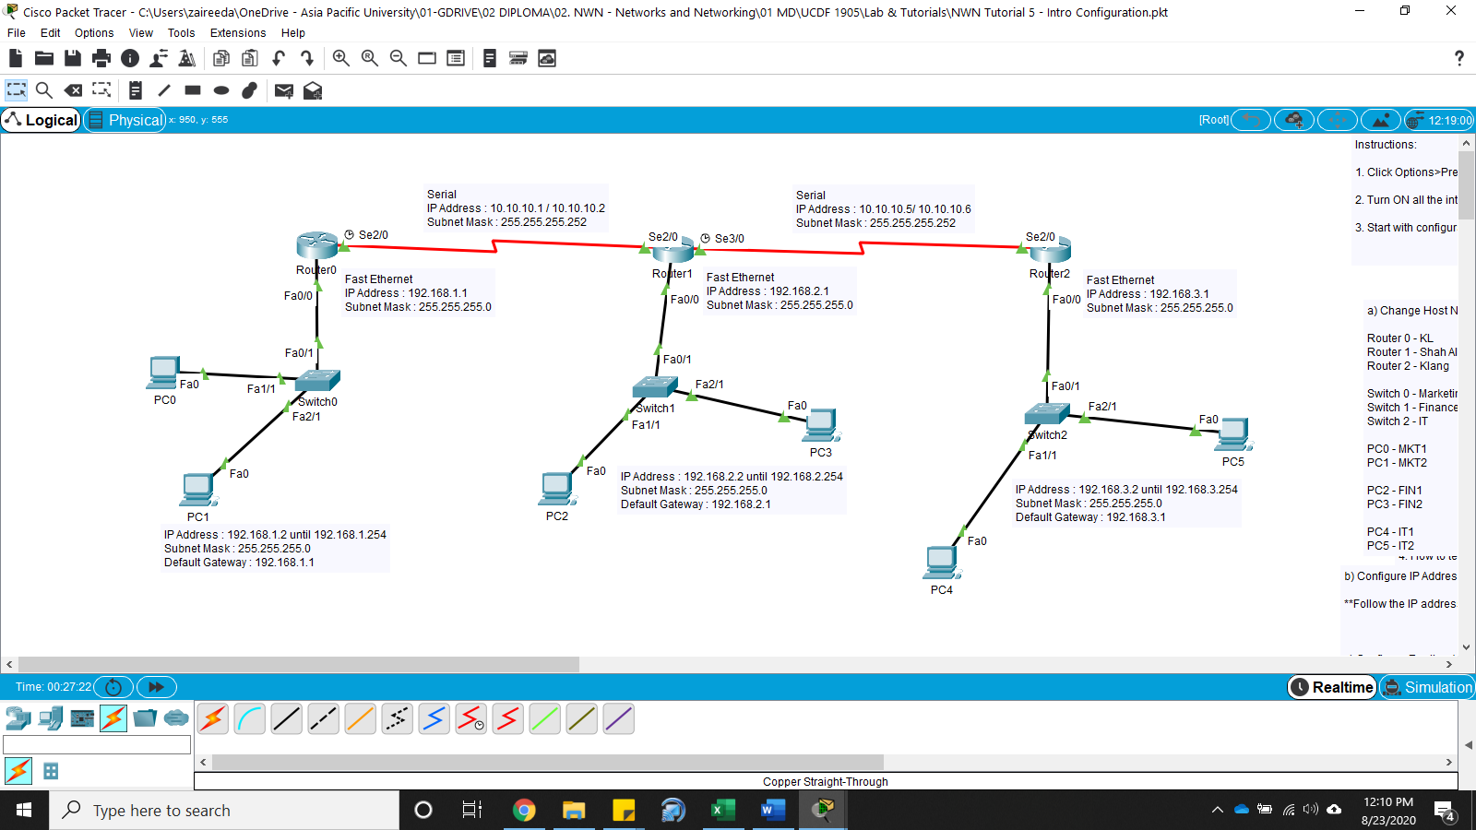

Figure 1 – Network Design

1. Before beginning *Click Options>Preferences> Tick at Always Show Port Labels*
2. Select devices

Router – *PT-Router*

Switch – *PT-Switch*

PC – *PC*

1. Select cable for connections

Router to Router connection – *Serial DCE*

Router to Switch – *Copper Straight-Through*

Switch to PC – *Copper Straight-Through*

1. Change host name

|  |  |  |
| --- | --- | --- |
| Router 0 - KL  Router 1 - Shah Alam  Router 2 - Klang | Switch 0 - Marketing  Switch 1 - Finance  Switch 2 - IT | **Change the display name**  PC0 - MKT1  PC1 - MKT2  PC2 - FIN1  PC3 - FIN2  PC4 - IT1  PC5 - IT2 |

1. Configure IP address

As per Network Design